# Week2 Binary Classification

1. Introduction to Binary Classification

False positive, false negative =>great costs

ROC Curve( Receiver Operating Characteristic Curve): estimate of the relative cost of the two different kinds of mistakes, maximize the area under the ROC curve=> discriminate signal from noise

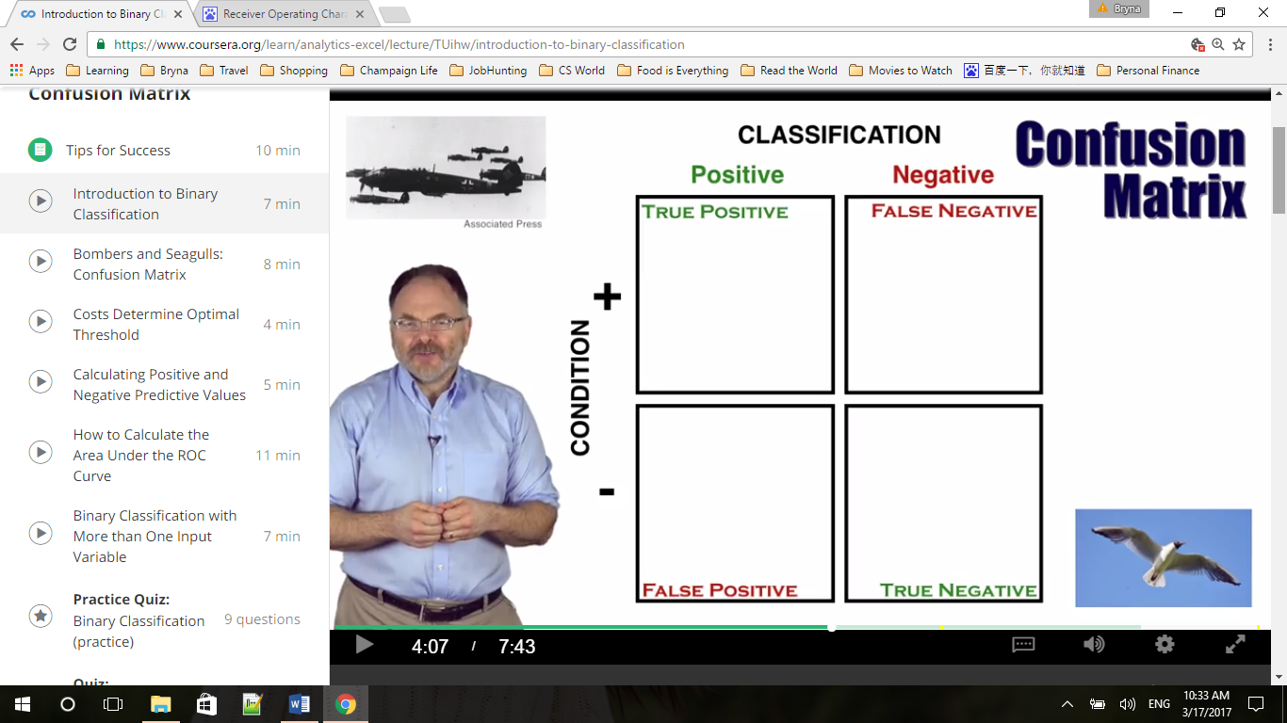

Note that a false positive rate is the total number of false positive classifications, divided by total number of seagulls. The true positive rate is the total number of true positive classification, divided by the total number of bombers.

FPR = FP/(FP+TN) 假正类率

TPR = TP/(TP+FN) 真正类率

TNP = TN/(FP+TN) 真负类率 1-FPR

Keeping the scoring method constant but changing the threshold leads to different values for the confusion matrix.

Area under the Curve of ROC (AUC ROC)

1. Bombers and Seagulls: Confusion Matrix

Appendix: 2.1

First Use - Exploring the relationship between Classification Errors, the ROC Curve and the Area under the Curve (AUC)

Interact with the Bombers and Seagulls spreadsheet to see how changing the number of classification errors changes the false positive and true positive rates, the shape of the resulting Receiver Operating Characteristic Curve, and the overall Area Under the Curve (AUC).

On the Spreadsheet, ranked scores corresponding to the size of radar images are given in Column C, rows 33 to 52.

The actual condition – Bomber or Seagull – that goes with each score is given in Column D, rows 33 to 52.

This spreadsheet is a calculator that measures the number of incorrect and correct positive classifications at each threshold to generate a false positive rate – Column H, rows 32 to 52 – and a true positive rate – Column I, rows 32 to 52.

At each threshold dividing positive from negative classification, the false positive rate and true positive rate provide an (x,y) ordered pair. These ordered pairs, when shown on a chart and linked together, form the ROC Curve.

These ordered pairs are shown in Columns D and E, rows 6 to 26 – and are displayed on the chart at columns K-N.

The total area under the resulting ROC curve - the very important AUC Metric - is given in cell I28.

Try an experiment yourself – what if the event with radar score “83” had turned out to be seagull and not a bomber? This change would result in one more false positive classification and one fewer true positive classification for every threshold of 83 or below.

How would this impact the performance metrics for the radar? Replace the condition “1” in cell D37 with a “0.” Note that almost all the false positive and true positive rates at different thresholds change. You can observe how the shape of the ROC Curve on the chart changes, and how the area under the curve is reduced from .824 to .806.

Next, try changing the event with radar score 97 from a seagull to a bomber – by replacing the “0” in cell D33 with a “1.” This should improve the area under the curve from .824 to .906.

Second Use - exploring how changing the input “Costs per Classification error” changes the overall cost, and changes the optimum (lowest-cost) threshold

The Bombers and Seagulls Spreadsheet can also be used to observe how, keeping the threshold constant, changing the costs per false negative classification and per false positive classification changes the total cost of a classification system. It can also lead to a different threshold becoming the lowest-cost threshold.

Spreadsheet cell L30 contains the cost per False Negative (FN) – recall that this means failure to signal an alarm when bombers attack.

Cell N30 contains the cost per False Positive (FP) – the cost of responding to a false alarm.

The total costs over all 20 events, at each different possible threshold for binary classification, are given in Column O, rows 32 to 52.

The minimum total cost – the cost if selecting the “optimum” threshold – is given in cell O54.

To identify the optimum threshold using this spreadsheet, find the row in Column O that has the same total cost as the minimum cost given in row 54. Cell P54 shows the lowest average cost per event - the total cost, divided by the total number of events.

At the default settings of 10 million pounds per FN and 4 million pounds per false positive, the minimum total cost - 20 million pounds – is found in cell O40, which uses the Excel “min” function on the list of totals.

Now look across the spreadsheet to column C in the same row. Cell C40 shows that the optimum threshold at the default costs levels classifies 75 and above as “positive” and 74 and below as “negative.”

The total cost of 20 million pounds is due to 5 False Positive errors at 4 million pounds each, and 0 False Negatives errors at 10 million pounds each. The classification errors can be seen in Column D, rows 33, 35, 36, 38 and 39.

Now, try changing the cost per FN in cell L30 from 10 million pounds to 5 million pounds. Keep the cost per FP the same for now.

The new minimum total cost displayed in cell O54 is now 14 million pounds. Note that the minimum is no longer at 040. The new minimum-cost is found in cell O34. This corresponds to the threshold in cell C34. The new optimum threshold classifies 93 and above and positive and 90 and below as negative.

--------------------------------------------------------------------------------------------------------------------------------

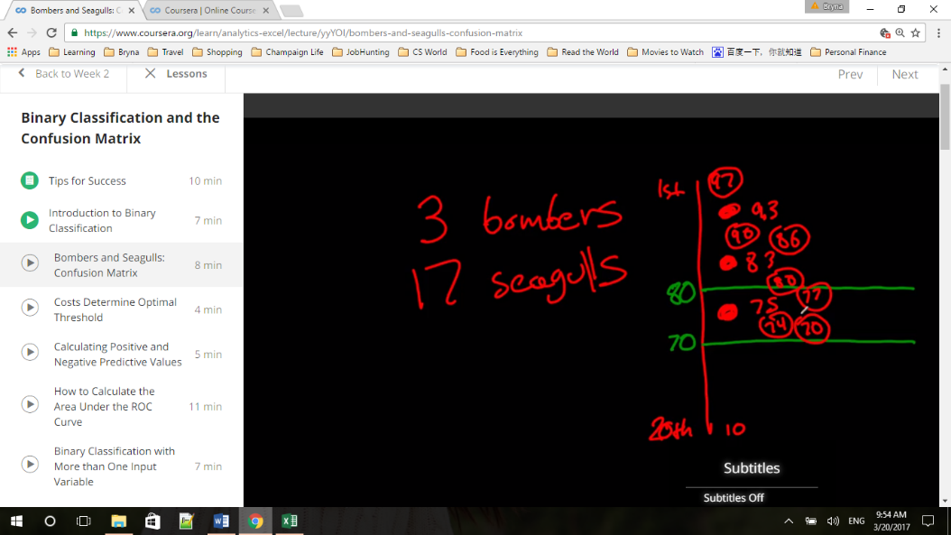The total cost of 14 million pounds is now due to one False Positive error (cell D33) at 4 million pounds and two False Negative errors (at cell D37 and D40) at 5 million pounds each.

Threshold => determine who many false alarms we have

80=> 4 false alarms, 97, 90, 86, 80; 2 true positive

70=> 7 false alarms, 97, 90, 86, 80, 77, 74, 70; all 3 true positive

Not radar but radar and a threshold => determine how many values go into each of these boxes

1. Costs Determine Optimal Threshold

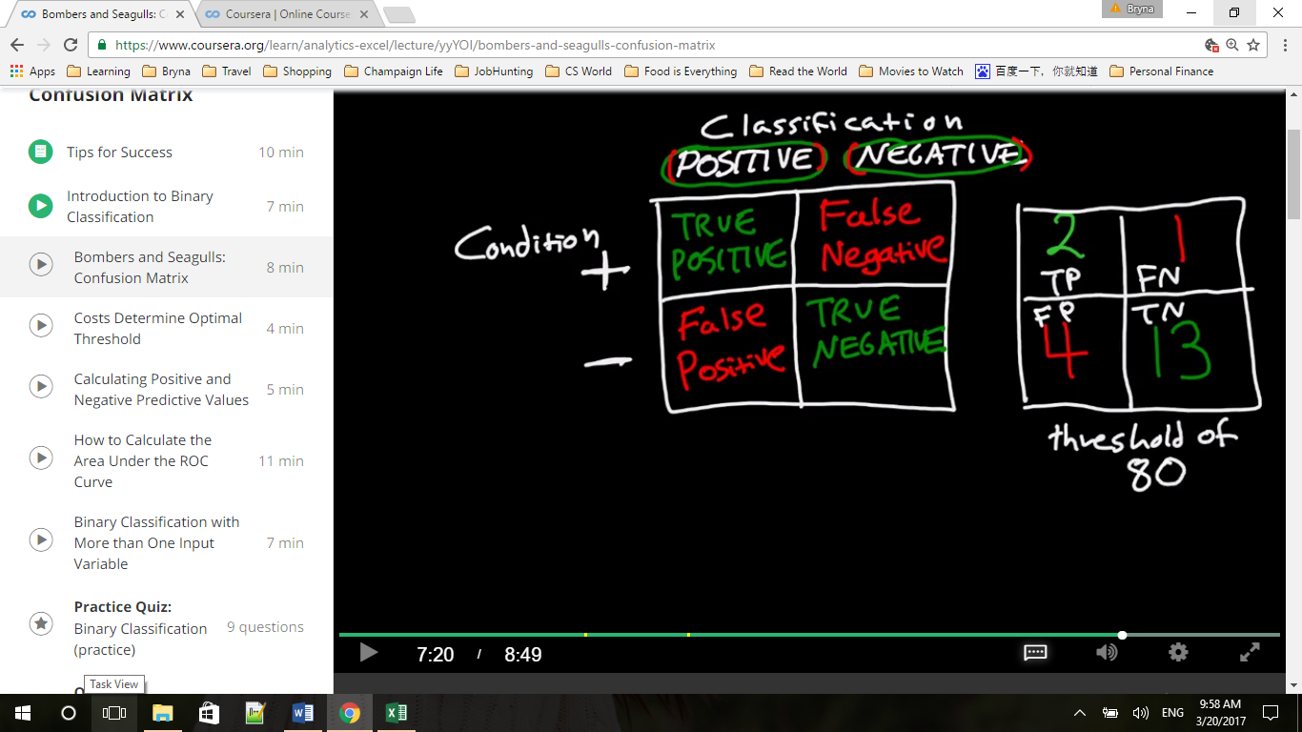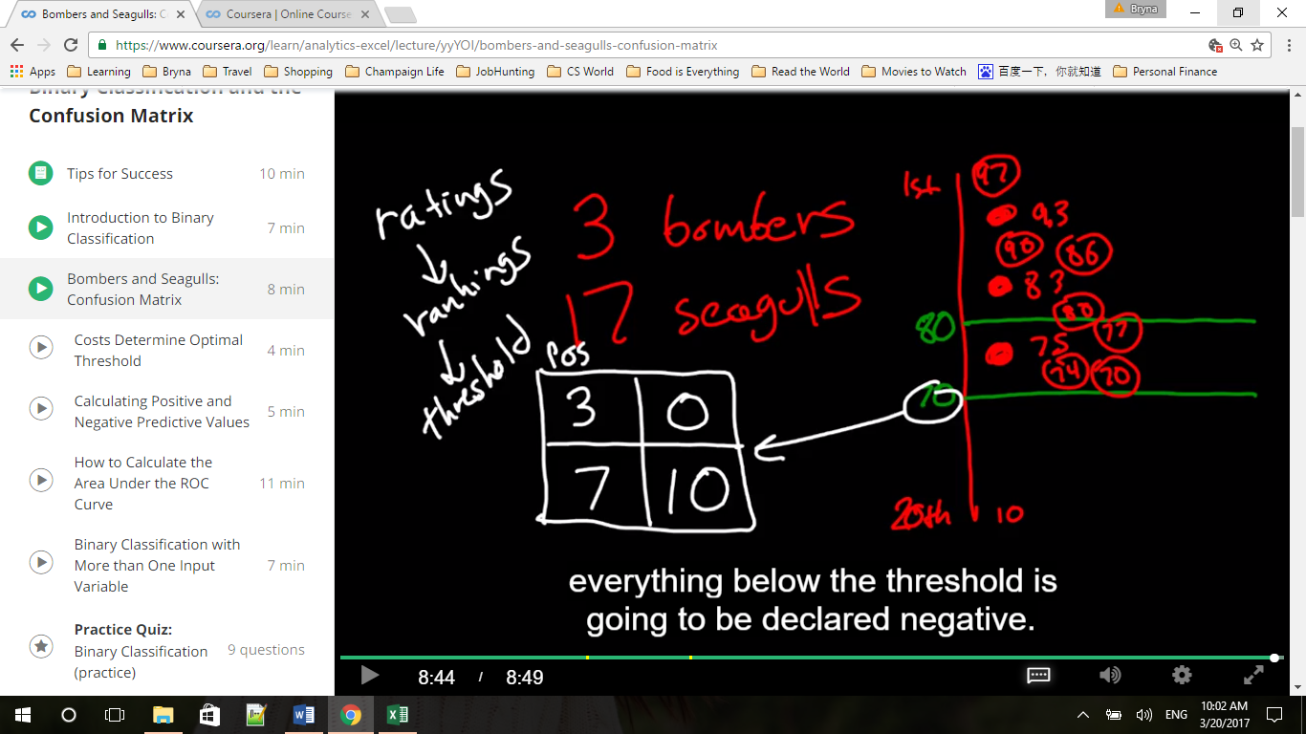

Threshold 80: FPR = FP/(FP+TN)= FP/Neg = 4/17 =

TPR = TP/(TP+FN) = TP/Pos = 2/3 =

Threshold 70: FPR = FP/(FP+TN)= FP/Neg = 7/17 =

TPR = TP/(TP+FN) = TP/Pos = 3/3 = 1

X = FPR, Y = TPR

1. Calculating Positive and Negative Predictive Values

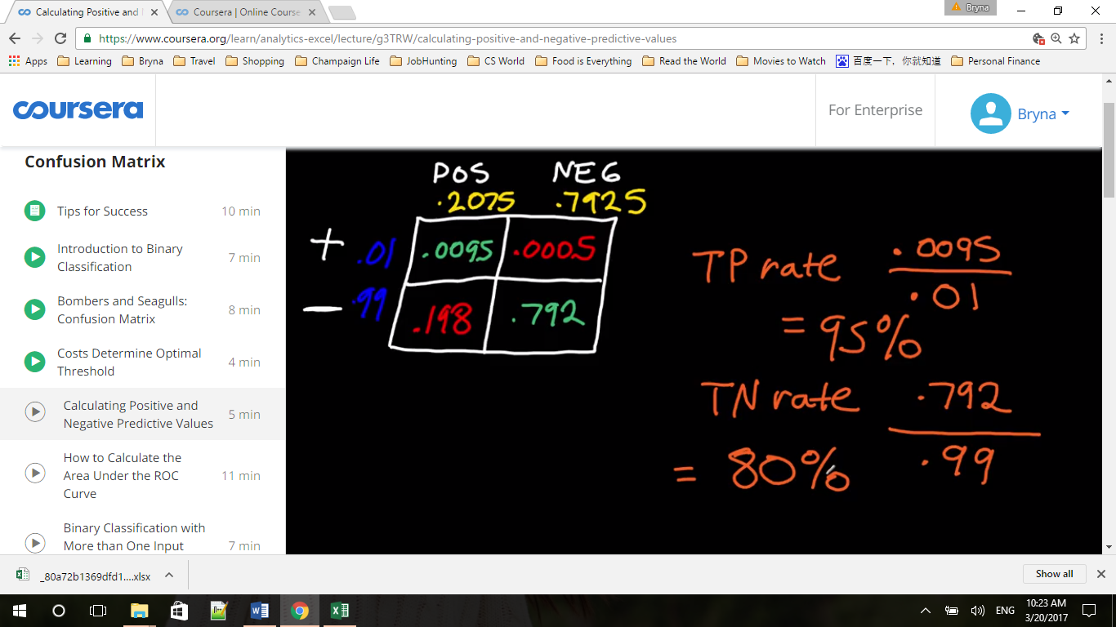

A true positive rate of 95% is conditional probability of having a having a positive test if I have cancer. And true negative rate is the p of having a negative test if I do not cancer.

What we want to know here is the latter: the conditional probability that we have the cancer if I have a positive test, or I don’t have cancer if I have a negative test?

P(POS TEST / + ) VS P( + / POS TEST)

P(NEG TEST/ - ) VS P( - / NEG TEST)

前者是说，我有病能测出来的准确率，后者是我测出来有病而我实际有病的准确率，不一样

计算方法：前者TP除以所有实际的True（上面两格）,后者TP除以测出来的Pos(左侧两格)

The latter is called positive predictive value (green yellow )

= 0.095/0.2075 = 4.58%, if I received a positive test, I have a 4.58% chance of having cancer

negative predictive value = 0.792/0.7925 = 99.937%, means that if the test turns out negative, I have 99.937% chance of not having cancer, 0.063% chance of having cancer

--------------------------------------------------------------------------------------------------------------------------------

Appendix 2.3

This spreadsheet works just the same way as the example shown in the Bombers and Seagulls Spreadsheet (and the video) but has 10,000 rows of data instead of 20. It is designed to provide a realistic simulation of the cost-benefit assumptions that must be made to set the classification threshold for a medical diagnostic product.

The ranked scores in Column A are the level of a certain protein as measured by the diagnostic test.

The true Condition for each protein level score is given in Column C [Cancer =1, No Cancer = 0].

A threshold for positive classification can be set between any two protein levels. For each threshold given in Column A, the resulting number of False Negative classification errors is given in the same row of Column H, and the False Positive classification errors in the same row of Column F.

This spreadsheet is designed to allow you to observe how changing cost inputs impacts both (a) the overall costs of using a cancer diagnostic test at each threshold, and (2) what threshold should be chosen as optimal (minimizing cost).

The cells to input the assumed costs of classification errors are Cell G3 for cost per False Negative (missing a case of cancer) and H3 for cost per False Positive (a false alarm). Total costs at each threshold are given in Column K.

The minimum total cost, and minimum cost per event (per diagnostic classification reported), are displayed in cells K4 and L4, and the optimum threshold – the lowest protein level score that should be classified positive - is displayed in cell M4.

At the default costs of $50,000 per False Negative error and $500 per False Positive error, the minimum cost per event is $119.90, and the optimal threshold for positive classification is 16551.930.

Try changing the inputs yourself. If you keep the cost per False Negative the same, but raise the cost per False Positive, would you in general expect the new optimum threshold to be higher (fewer total positive classifications) or lower (more total positive classifications)?

Change the cost per False Positive to $1500 and you will see that the optimum threshold is higher. The threshold for the first Positive classification moves from 16551.930 [item ranked 2094] to 16824.137 [item ranked 1822].

Similarly, if you reset the cost per FP at $500 and raise the cost per FN to from $50,000 to $500,000, the optimal threshold is lower – it falls to 13307.537 [item ranked 5338]

1. How to Calculate the Area Under the ROC Curve

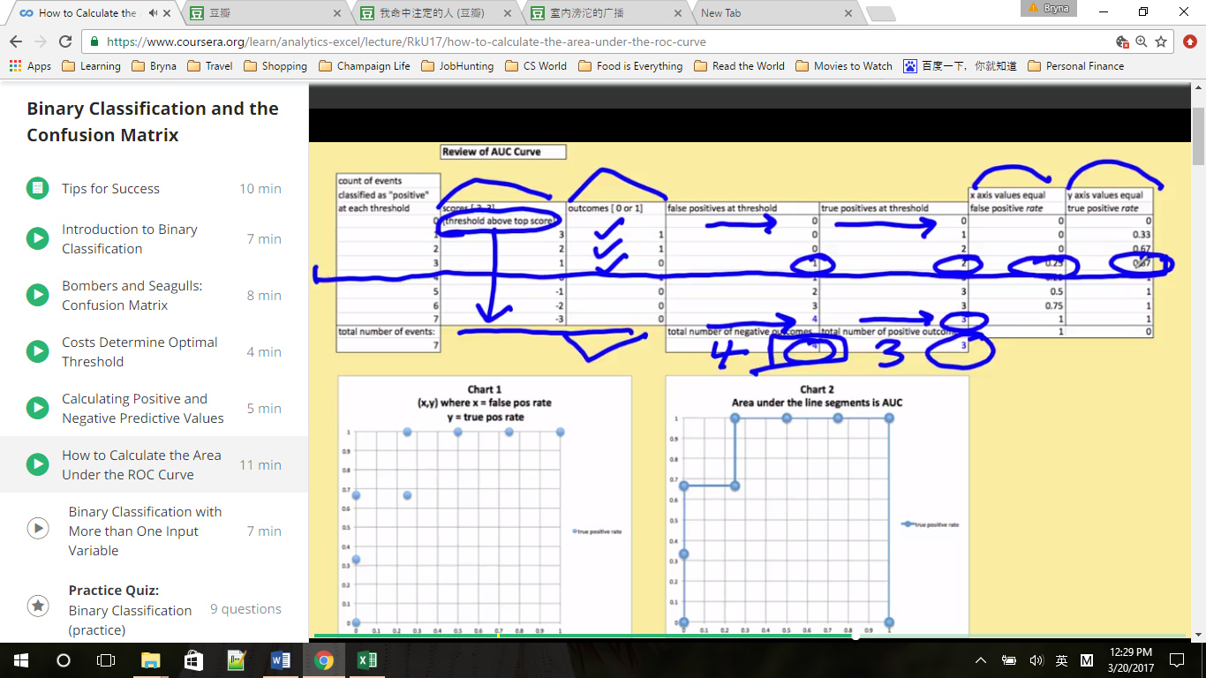

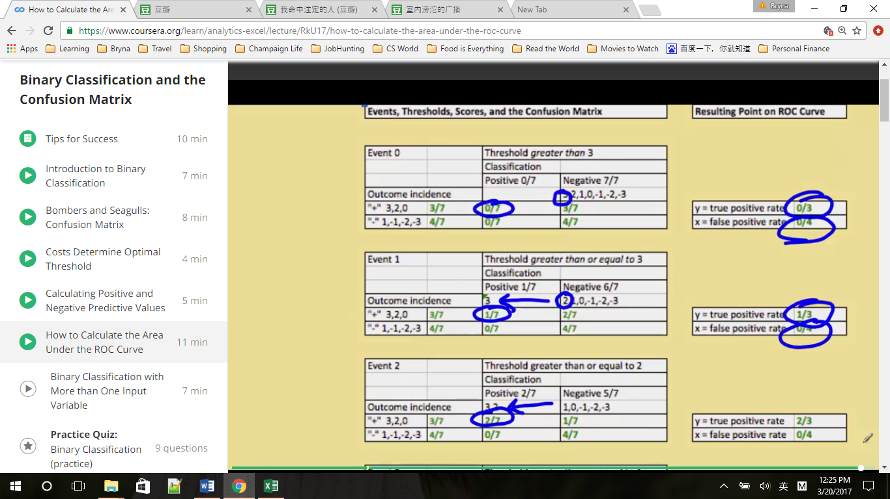

--------------------------------------------------------------------------------------------------------------------------------

Appendix 2.4

Input any value between 0 and 1 for the probability of True Positive classifications – the joint probability labeled letter e in the confusion matrix – into cell G9.

Next, enter any valid values (that is, any values less than or equal to the value entered into cell G9) for the condition incidence – letter a - (cell E9) and the “classification incidence” (also called “test incidence”) – letter c - (cell G7).

The Excel Spreadsheet will output:

-Values for the remaining five cells of the Confusion Matrix, designated by letters b, d, f, g, and h.

-Values for the eight primary performance metrics used to evaluate binary classification systems, Column F, rows 36-39 and 41-44.

-One point on the ROC Curve corresponding to this particular Confusion Matrix. Recall that the x-axis coordinate equals the False Positive Rate – output in Cell N37 – and the y axis coordinate equals the true positive rate – output in Cell O37.

Assume the Confusion Matrix shows the performance of a model that tries to predict which visitors to an Automobile dealership will buy a car from that dealer.

Experiment with how a change in one or more inputs impacts the outputs. For example, change the probability that an event will be a True Positive [Cell G9] to .18, without changing the condition incidence or test incidence.

Question: What is the conditional probability that a visitor classified as Positive by the predictive model (the “test”) will buy a car (the condition)?

Answer: 90%. The answer is the “Positive Predictive Value” – also written as the conditional probability p ("+" | Test POS) – as is found in cell F41, is 0.9.

Question: What point on the ROC Curve summarizes this confusion matrix performance? Answer:

Answer: (.03, .6). The value 3% is the False Positive rate – also written as the conditional probability p(Test POS | "-") – found in Cells N37 and F38. The value 60% is the true positive rate – also known as the conditional probability p(Test POS | "+") - Given in cells O37 and F36.

Question: What is the probability that a visitor classified as “Negative” by the predictive model will not buy a car from that dealer?

Answer: 85%. This value is the Negative Predictive Value, also written as the conditional probability p("-" | Test NEG) – found in Cell F44.

1. Binary Classification with More than One Input Variable

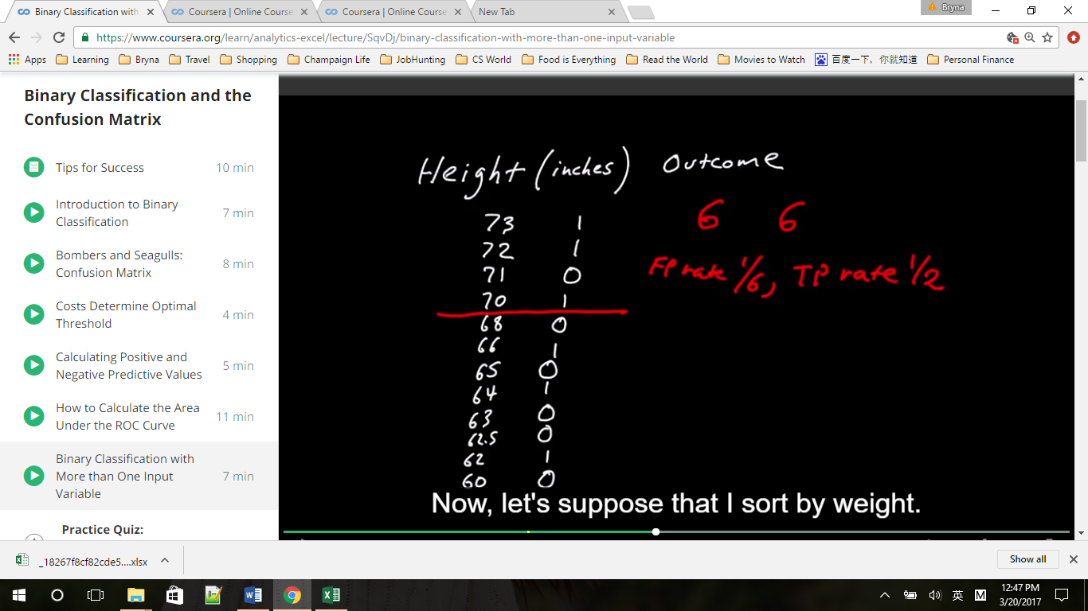 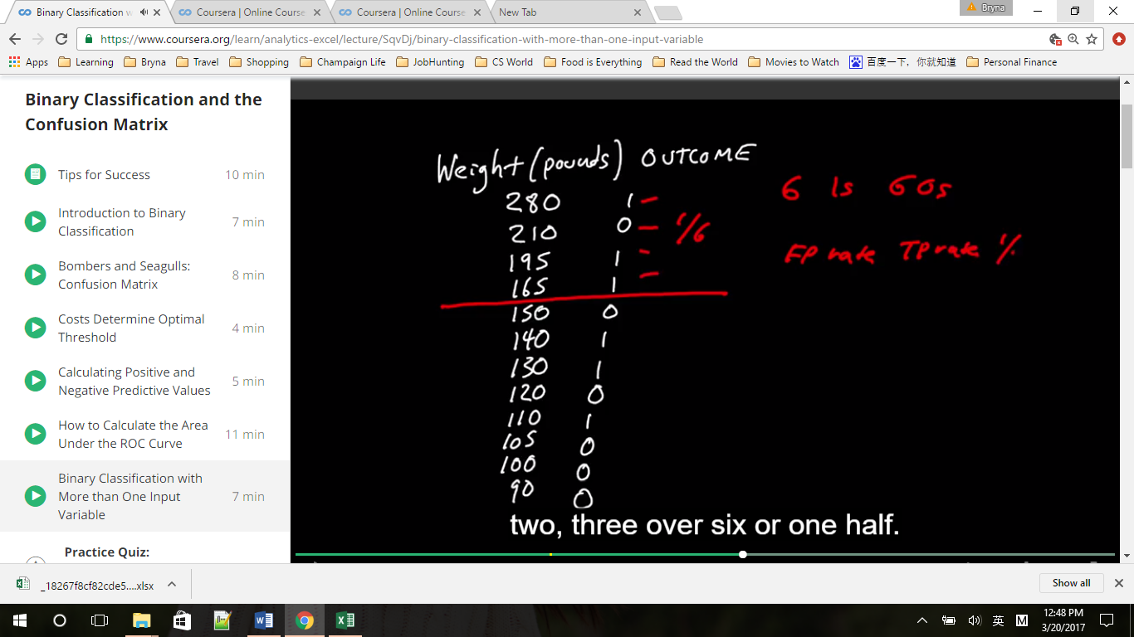

When you combine variables that have very different scales, first standardized them to figure out how much relative weight you should assign to each one. If we just add height and weight together, the weight swamp the results, nearly the same outcome based on weight only.

Why standardizing the data? To treat each of the two input variables as equally important

--------------------------------------------------------------------------------------------------------------------------------

Appendix 2.6

This Spreadsheet can be used to practice sorting data so that it is ordered by the “score” used for predictive purposes. Copy cells B18 to G30 and “paste special: values and number formats.” Past into the upper left hand corner of a new spreadsheet. Then select the right-most Column – containing the sum of standardized heights and weights – and choose Data/Sort/Descending – when asked, choose “Expand the selection.” You will now have created a ranked set of scores and outcomes, just like what is already provided in the Bombers and Seagulls and Cancer Diagnostics Spreadsheets. Repeat the process but sort on height alone, on weight alone, or on a combination of height and weight not previously standardized (Column G, rows 2 – 13) to compare the performance of the various scores when used for binary classification.